**Flatten a Multilevel Doubly Linked List: -**

You are given a doubly linked list which in addition to the next and previous pointers, it could have a child pointer, which may or may not point to a separate doubly linked list. These child lists may have one or more children of their own, and so on, to produce a multilevel data structure, as shown in the example below.

Flatten the list so that all the nodes appear in a single-level, doubly linked list. You are given the head of the first level of the list.

NOTE:- You need to take care of all the pointers. The final output list should be free from child pointers. Do not forget to make the child pointers NULL and also take care of all the prev pointers.

**Example 1:**

**Input:** head = [1,2,3,4,5,6,null,null,null,7,8,9,10,null,null,11,12]

**Output:** [1,2,3,7,8,11,12,9,10,4,5,6]

**Explanation:**

The multilevel linked list in the input is as follows:

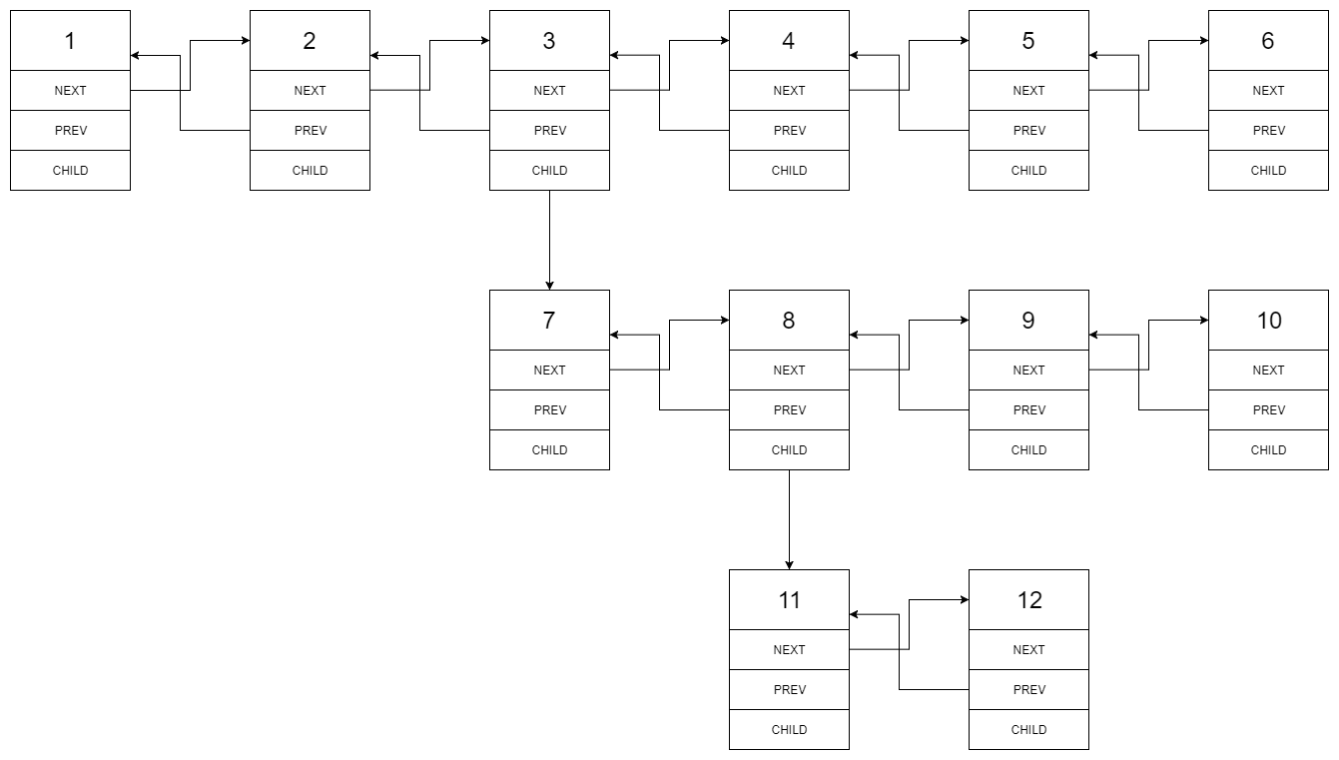

After flattening the multilevel linked list it becomes:



**Example 2:**

**Input:** head = [1,2,null,3]

**Output:** [1,3,2]

**Explanation:**

The input multilevel linked list is as follows:

1---2---NULL

|

3---NULL

**Example 3:**

**Input:** head = []

**Output:** []

**How multilevel linked list is represented in test case:**

We use the multilevel linked list from **Example 1** above:

1---2---3---4---5---6--NULL

|

7---8---9---10--NULL

|

11--12--NULL

The serialization of each level is as follows:

[1,2,3,4,5,6,null]

[7,8,9,10,null]

[11,12,null]

To serialize all levels together we will add nulls in each level to signify no node connects to the upper node of the previous level. The serialization becomes:

[1,2,3,4,5,6,null]

[null,null,7,8,9,10,null]

[null,11,12,null]

Merging the serialization of each level and removing trailing nulls we obtain:

[1,2,3,4,5,6,null,null,null,7,8,9,10,null,null,11,12]

**Constraints:**

* Number of Nodes will not exceed 1000.
* 1 <= Node.val <= 10^5